TITLE

DESIGN AND IMPLEMENTATION OF A MOTOR SPEED DIGITAL CONTROL SYSTEM

APPROVAL PAGE
DESIGN AND IMPLEMENTATION OF MOTOR SPEED DIGITAL CONTROL SYSTEM
This project has been supervised and is certified as satisfying in part, the requirement for the award of Bachelor of Engineering Degree (B.Eng.) in Electronic Engineering, Department of Electronic Engineering, University of Nigeria, Nsukka.
SIGNATURE OF AUTHORS: ______________________________________________
NNAMANI BRIGHT .N. (2009/165408)
_______________________________________________
DIKE LINDA .N. (2009/168532)

CERTIFIED BY: _______________________________________________
ENGR. M.A. AHANEKU DATE
(SUPERVISOR)

ACCEPTED BY: ________________________________________________
PROF. C.I. ANI DATE
(HEAD OF DEPARTMENT)
DEDICATION
This project is dedicated to our families for their immense support and to our supervisor for his tremendous contributions to making this project a success.

ACKNOWLEDGEMENT
We wish to acknowledge our project supervisor, Engr. M.A. Ahaneku for his unrelenting guidance and support during the course of this project and also, the Head of Department, Electronic Engineering and our Academic adviser, Prof. C.I. Ani. We also acknowledge our parents for their financial and moral support.

ABSTRACT
Control system design and analysis technologies are widely suppress and very useful to be applied in real-time development. Some can be solved by hardware technology and by the advance used of software, control system are analyzed easily and detail. DC Motors can be used in various applications and can be used as various sizes and rates as per our applications. In this project we have control the actual speed of dc motor as per ours requirement. This can be achieved through PIC microcontroller. The speed of the motor sensed by using a tachometer (optical tachometer) with which the speed is counted and the corresponding pulses sent to the microcontroller where the Rpm is calculated and displayed on LCD. In this project firstly we are giving the supply to PIC microcontroller. Then the microcontroller generates the pulse generally 5 volt DC. The generated pulse is a pulse width modulated signal (PWM) which is fed to driver circuit. The function of this driver circuit is to generate 12v DC pulse. This is necessary to switch/triggering on MOSFET. Thus speed of DC motor is controlled through duty/PWM cycle. This PWM pulse is then fed to the MOSFET for triggering purpose. The modeling and simulation of this project was done through Mikroc and Proteaus professional software. The microcontroller then compares the actual speed of the motor with the reference speed and generates a suitable control signal which is fed into the triggering unit to keep the motor speed constant at the reference speed.

TABLE OF CONTENTS
TITLE PAGE…………………………………………………………………………….…i
APPROVAL PAGE………………………………………………………………………..ii
DEDICATION………………………………………………………………………...…..iii
ACKNOWLEDGEMENT…………………………………………………………………iv
ABSTRACT……………………………………………………………………………..…v
TABLE OF CONTENTS…………………………………………………………………..vi
LIST OF FIGURES………………………………………………………………………..vii
LIST OF TABLES…………………………………………………………………………viii
CHAPTER ONE: INTRODUCTION……………………………………………………...1
1.0 BACKGROUND……………………………………………………………………...1
1.1 STATEMENT OF PROBLEM......................................................................................2
1.2 OBJECTIVE OF PROJECT..........................................................................................2 1.3 SIGNIFICANCE OF STUDY.......................................................................................2 1.4 SCOPE OF PROJECT...................................................................................................3 1.5 REPORT LAYOUT.......................................................................................................4
CHAPTER TWO: LITERATURE REVIEW...............................................................5
2.0 CONCEPT OF CONVENTIONAL DC MOTOR................................................5
2.1 CONCEPT OF ELECTRIC MOTOR DRIVES...........................................................7
2.2 DC MOTOR DRIVE....................................................................................................8
2.2.1 FOUR QUADRANT MOTOR OPERATIONS..........................................................10
2.3 CONSIDERATIONS FOR CONVERTER DRIVEN DC MOTORS.......................11
2.3.1 DEVICE CURRENT RATING.................................................................................11
2.3.2 DEVICE VOLTAGE RATING................................................................................12
2.3.3 MOTOR PERFORMANCE.......................................................................................12
2.4 COMPARISON BETWEEN DC AND AC DRIVES...............................................13
2.4.1 MOTORS.....................................................................................................................13
2.4.2 CONTROL UNIT........................................................................................................13
2.4.3 PERFORMANCE.......................................................................................................14
2.5 CONCEPT OF DIGITAL CONTROL DRIVES........................................................14
2.6 CONCEPT OF PULSE WIDTH MODULATION (PWM)........................................15
2.7 SPEED CONTROL - PWM TECHNIQUE..............................................................16
2.7.1 FREQUENCY.............................................................................................................16 2.7.2 DUTY CYCLE...........................................................................................................16

2.8 SPEED SENSOR MOTIONS....................................................................................17 2.8.1 OPTICAL SENSOR..................................................................................................17 2.8.2 MAGNETIC SENSOR..............................................................................................18 2.9 THE PIC MICROCONTROLLER............................................................................19 2.9.1 MICROCONTROLLERS VERSUS MICROPROCESSORS...................................19 2.9.2 MEMORY UNIT.........................................................................................................19 2.9.3 CENTRAL PROCESSING UNIT.............................................................................20 2.9.4 BUS.............................................................................................................................21 2.9.5 INPUT-OUTPUT UNIT.............................................................................................22 2.9.6 SERIAL COMMUNICATION..................................................................................22 2.9.7 TIMER UNIT..............................................................................................................24 2.9.8 WATCHDOG..............................................................................................................25 2.9.9 ANALOG TO DIGITAL CONVERTER...................................................................25

CHAPTER THREE: SYSTEM DESIGN.............................................................................28 3.0 INTRODUCTION........................................................................................................28 3.1 BLOCK DIAGRAM REPRESENTATION OF THE SYSTEM..................................29 3.2 SPECIFIC SPECIFICATIONS.....................................................................................30 3.3 SYSTEM DEVELOPMENT.........................................................................................30 3.3.1 THE POWER SUPPLY UNIT.....................................................................................30 3.3.1.1 TRANSFORMATION STAGE..................................................................................31 3.3.1.2 RECTIFICATION STAGE .......................................................................................31 3.3.1.3 FILTERING STAGE..................................................................................................32 3.3.1.4 REGULATION STAGE.............................................................................................33 3.3.2 THE MICROCONTROLLER.......................................................................................33 3.3.2.1 PWM SIGNAL GENERATION FROM THE MICROCONTROLLER..................34 3.3.3 THE ALPHANUMERIC LCD.....................................................................................34 3.3.3.1 THE ALPHANUMERIC INTERFACING WITH THE MICROCONTROLLER.........................................................................................................35 3.3.4 THE MOSFET DRIVER CIRCUIT CONFIGURATION........................................36 3.3.5 THE MOSFET............................................................................................................37 3.3.6 THE MOSFET DRIVING CIRCUIT......................................................................38 3.3.7 THE MOTOR SPEED SENSING TECHNIQUE......................................................38 3.3.8 PROGRAMMING THE MICROCONTROLLER...................................................39 3.3.9 PRINCIPLE OF OPERATIONS OF THE CIRCUIT...............................................43 3.4 S0FTWARE DEVELOPMENT.................................................................................44
CHAPTER FOUR.................................................................................................................48
- CONSTRUCTION, TESTING AND RESULTS..........................................................48
4.1 CONSTRUCTION.........................................................................................................48 4.1.1 THE POWER SUPPLY CIRCUIT...............................................................................48 4.1.2 MICROCONTROLLER CONFIGURATIONS AND INTERFACING.....................49 4.1.3 MOTOR DRIVER CONSTRUCTION.........................................................................51 4.1.4 MOTOR SPEED SENSOR CONFIGURATION.........................................................52 4.2 TESTING AND RESULTS..............................................................................................52 4.2.1 CHALLENGES AND SOLUTIONS............................................................................53 4.3 LIMITATIONS OF THE DESIGN..................................................................................54

CHAPTER FIVE: COST ANALYSIS, CONCLUSION AND RECOMMENDATIONS.......................................................................................................55 5.0 COST ANALYSIS...........................................................................................................55 5.1 CONCLUSION AND RECOMENDATION..................................................................56 5.1.1 RECOMMENDATIONS..............................................................................................57

APPENDIX

REFERENCES

LIST OF FIGURES
Figure 2.1: Conventional (brushed) d.c motor..........................................................................5 Figure 2.2: Conventional variable speed electrical drive system...............................................7 Figure 2.3: Modern electric motor drive system employing power electronic converters........8
Figure 2.4: Separately excited d.c motor..................................................................................10
Figure 2.5: D.C motor operating characteristics......................................................................10
Figure 2.6a: Two quadrant operation………………………………………………………10
Figure 2.6b: Four quadrant operation………………………………………………………..10
Figure 2.7: Four quadrant full bridge circuit…………………………………………………11
Figure 2.8: Pulse width modulated signal for d.c motor drive………………………………17
Figure 2.9: Example of a simplified memory unit…………………………………………..19
Figure 2.10: Diagram of simplified CPU with three registers……………………………….20
Figure 2.11: Diagram of connection between memory and central unit using busses………21
Figure 2.12: Example of a simplified input-output unit providing communication…………22 Figure 2.13: A serial unit used to send data…………………………………………………23
Figure 2.14: A timer unit…………………………………………………………………….24
Figure 2.15: A watchdog……………………………………………………………………25
Figure 2.16a: Diagram of a block from an analogue to a digital form………………………26
Figure 2.16b: Physical configuration of the interior of a microcontroller………………….26
Figure 2.17: Microcontroller outline with its basic elements and internal connections……27
Figure 3.1: Block diagram of the design...............................................................................29
Figure 3.2: Transformer winding..........................................................................................31
Figure 3.3: Diode bridge rectifier…………………………………………………………..32
Figure 3.4: Power supply circuit diagram………………………………………………….33
Figure 3.5: 16x2 liquid crystal display.................................................................................34
Figure 3.6: Circuit diagram of a mosfet driver……………………………………………...36
Figure 3.7: Diagram of a mosfet…………………………………………………………….37
Figure3.8: The motor driving circuit………………………………………………………..38
Figure 3.9a: Optical speed sensor circuit…………………………………………………….39
Figure 3.9b: Physical diagram of the optical sensor……………………………………….39
Figure 3.10: Program flow diagram..................................................................................…...40
Figure 3.11: Design circuit diagram………………………………………………………….42
Figure 4.1: Pin-out diagram of PIC18F2550............................................................................49
Figure 4.2: Microcontroller interface diagram.........................................................................50
Figure 4.3: Motor driver circuit diagram..................................................................................51
Figure 4.4: Motor speed sensing circuit...................................................................................52 Figure 4.5: Diagram of the soldered work front view..............................................................53

LIST OF TABLES
Table 3.2: Specific specifications -----------------------------------------------------------------30
Table 5.0: Cost analysis-----------------------------------------------------------------------------55

CHAPTER ONE
INTRODUCTION
1.0 Background
Control system design and analysis technologies are widely surpass and very useful to be applied in real-time development. Some can be solved by hardware technology and by the advanced use of software. Control systems are analyzed easily and detailed. DC Motors can be used in various applications and can be used in various sizes and rates as per our applications. The DC-Motor is used in domestics and industrial purposes. Whenever we think about any programmable devices then the embedded technology comes into forefront. The embedded in recent days very much popular and most of the products are developed with Microcontroller -based embedded technology. The advantages of using the microcontroller is the reduction of the cost and also the use of extra hardware such as RAM and ROM can be avoided.
This technology is very fast so that controlling of multiple parameters is possible; also the parameters are field programmable by the user. In this project efforts are geared towards controlling speed of DC motor. As the speed of DC motor is increased, there will be a proportional increase in the productivity of material. The application of this is used in domestic’s purpose examples are hair dryer, mixer, zero machine, elevator and industrial purposes. This project will demonstrate how to control the actual speed of dc motor as per our requirement. This can be achieved through PIC microcontroller. The microcontroller computes the actual speed of the motor by an interrupt routine program written to count, calculate the speed from the pulse generated from the optical speed sensor and display on the result on liquid crystal display (LCD).
The microcontroller is programmed to generate pulse width modulated signal. The pulse is sent to the driver circuit and the function of this driver circuit is to generate 12V dc pulse, this is necessary to switch/trigger the MOSFET. Thus the speed of the DC motor is controlled through duty/PWM cycle. This PWM pulse is fed to the MOSFET for triggering purpose and the modeling and simulation of this project is done through MIKROC/PROTEUS software. The microcontroller compares the actual speed of the motor with the reference speed and generates a suitable control signal which is fed into the triggering unit. This unit drives a Power MOSFET amplifier, which in turn supplies a PWM voltage to the dc motor. DC Motors are widely used in various applications.
1.1 Statement of problem
In industries like bottling, construction and other companies that make use of cranes and uses DC motor for motion control precision in speed of the motions are required for maximum efficiency thus the need to apply speed control technology applies.

1.2 Objective of project
The main objective of this project is to design a digital speed control system of DC Motor by using microcontroller. This system will be able to control the DC motor speed at desired speed regardless the changes of load.
1.3 Significance of study
This project provides a gate way to many digital control of moving electronic parts such as electro mechanics. This is important to mechatronics since movement requires control so as to maintain directions and accuracy. These controls are of much use in controlling motors like servo motors, DC motors, AC motors both single phase and three phases [1]
1.4 Scope of Project
The scope of this project includes using MIKROC to program microcontroller PIC 18F82550 which entails interfacing the speed counter an optical tachometer, a push button, an LCD and constructing the hardware for the system.
1.5 Report layout
This project write up comprises of five chapters. Chapter one deals with the introduction in which the concept of the work is been introduced, statement of the problem leading to the project, the scope of the project, significance of the project and most of all aims and objectives of the project. Chapter two presents the literature review of the key features of the work and as well conventional aspect of the work coupled with the theoretical views on the project. Chapter three discusses the methods adopted to accomplish the project starting from the power supply design down to the entire circuit; Chapter four describes the design analysis. It also discusses the implementation and testing of the circuit and the problems encountered with preferred solution. Chapter five presents the cost analysis, conclusion and recommendation for future work.

CHAPTER TWO
LITERATURE REVIEW
2.0 CONCEPT OF CONVENTIONAL DC MOTOR
Until the 1980s the conventional (brushed) d.c. motor was the automatic choice where speed or torque control is called for, and large numbers remain in service despite a declining market share that resects the move to inverter-fed induction motors [2]. Applications range from steel rolling mills, railway traction, to a very wide range of industrial drives, robotics, printers, and precision servos. The range of power outputs is correspondingly wide, from several megawatts at the top end down to only a few watts, but except for a few of the small low-performance ones, such as those used in toys, all have the same basic structure, as shown in FIG 2.1.
The motor has two separate circuits. The smaller pair of terminals connects to the Weld windings, which surround each pole and are normally in series: in the steady state all the input power to the Weld windings is dissipated as heat – none of it is converted to mechanical output power. The main terminals convey the ‘power’ or ‘work’ current to the brushes which make sliding contact to the armature winding on the rotor. The supply to the Weld is separate from that for the armature, hence the description ‘separately excited’.
As in any electrical machine it is possible to design a d.c. motor for any desired supply voltage, but for several reasons it is unusual to Wound rated voltages lower than about 6 V or much higher than 700 V [3]. The lower limit arises because the brushes (see below) give rise to an unavoidable volt-drop of perhaps 0.5–1 V, and it is clearly not good practice to let this ‘wasted’ voltage became a large fraction of the supply voltage. At the other end of the scale, it becomes prohibitively expensive to insulate the commutator segments to withstand higher voltages.
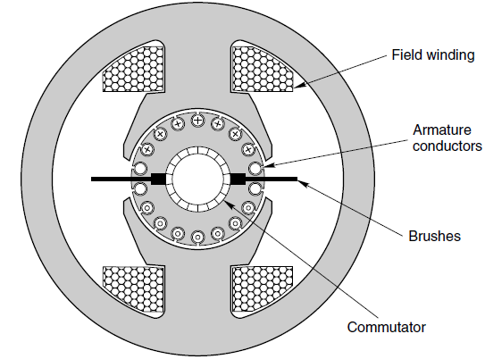
FIG 2.1 conventional (brushed) d.c motor
The function and operation of the commutator is discussed later, but troublesome at very high speeds. Small d.c. motors, say up to hundreds of watts output, can run at perhaps 12 000 rev/min, but the majority of medium and large motors are usually designed for speeds below 3000 rev/min.
Increasingly, motors are being supplied with power-electronic drives, which draw power from the a.c. mains and convert it to d.c. for the motor. Since the mains voltages tend to be standardized (e.g. 110 V, 220–240 V, or 380–440 V, 50 or 60 Hz), motors are made with rated voltages which match the range of d.c. outputs from the converter [4]. As mentioned above, it is quite normal for a motor of a given power, speed and size to be available in a range of divergent voltages. In principle, all that has to be done is to alter the number of turns and the size of wire making up the coils in the machine. A 12 V, 4 A motor, for example, could easily be made to operate from 24 V instead, by winding its coils with twice as many turns of wire having only half the cross-sectional area of the original. The full speed would be the same at 24 V as the original was at 12 V, and the rated current would be 2 A, rather than 4 A. The input power and output power would be unchanged, and externally there would be no change in appearance, except that the terminals might be a bit smaller. Traditionally d.c. motors were classified as shunt, series or separately excited. In addition it was common to see motors referred to as ‘compound-wound’ [5]. These descriptions date from the period before the advent of power electronics, and a strong association built up, linking one or other ‘type’ of d.c. machine with a particular application. There is really no fundamental divergence between shunt, series or separately excited machines, and the names simply resects the way in which the Weld and armature circuits are interconnected. The terms still persist, however, and we will refer to them again later. But Wrest we must gain an understanding of how the basic machine operates, so that we are equipped to understand what the various historic terms mean, and hence see how modern practice is deployed to achieve the same ends. We should make clear at this point that whereas in an a.c. machine the number of poles is of prime importance in determining the speed, the pole number in a d.c. machine is of little consequence as far as the user is concerned. It turns out to be more economical to use two or four poles in small or medium size d.c. motors, and more (e.g. ten or twelve or even more) in large ones, but the only divergence to the user is that the 2-pole type will have two brushes at 1808, the 4-pole will have four brushes at 908, and so on. Most of our discussion canters on the 2-pole version in the interests of simplicity, but there is no essential divergence as far as operating characteristics are concerned.

2.1 CONCEPT OF ELECTRIC MOTOR DRIVES
Drives are employed for systems that require motion control – e.g. transportation system, fans, robots, pumps, machine tools, etc. Prime movers are required in drive systems to provide the movement or motion and energy that is used to provide the motion can come from various sources: diesel engines, petrol engines, hydraulic motors, electric motors etc. Drives that use electric motors as the prime movers are known as electrical drives.
There are several advantages of electrical drives:
a. Flexible control characteristic – This is particularly true when power electronic converters are employed where the dynamic and steady state characteristics of the motor can be controlled by controlling the applied voltage or current.
b. Available in wide range of speed, torque and power
c. High efficiency, lower noise, low maintenance requirements and cleaner operation
d. Electric energy is easy to be transported.
A typical conventional electric drive system for variable speed application employing multi-machine system is shown in Figure 2.2. The system is obviously bulky, expensive, and inflexible and requires regular maintenance. In the past, induction and synchronous machines were used for constant speed applications – this was mainly because of the unavailability of variable frequency supply.
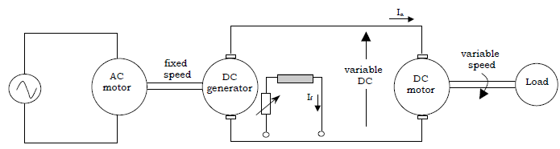
FIG 2.2 conventional variable speed electrical drive system
With the advancement of power electronics, microprocessors and digital electronics, typical electric drive systems nowadays are becoming more compact, efficient, cheaper and versatile – this is shown in Figure 2.3. The voltage and current applied to the motor can be changed at will by employing power electronic converters. AC motor is no longer limited to application where only AC source is available, however, it can also be used when the power source available is DC or vice versa[6]
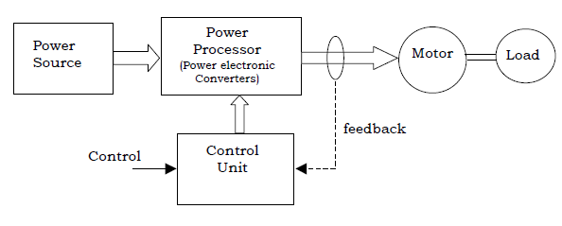
FIG 2.3 modern electric motor drive system employing power electronic converters

2.2 DC MOTOR DRIVE.
DC motor drives are used for many speed and position control systems where their excellent performance, ease of control and high efficiency are desirable characteristics. DC motor speed control can be achieved using switch mode DC-DC chopper circuits. For both mains-fed and battery supplied systems, power MOSFETs and FREDFETs are the ideal switching devices for the converter stage. The Philips range of Power MOS devices includes devices suitable for most DC-DC converters for motor control applications. Additionally, due to the ease with which MOSFETs and FREDFETs can be paralleled, Philips Power MOS devices can easily be used in chopper circuits for low power and high power DC motor drives for vehicle, industrial or domestic applications [7].
In a DC motor, the static field flux is established using either permanent magnets or a stator field winding. The armature winding, on the rotor of a dc machine, carries the main motor current. The armature winding is a series of coils, each connected to segments of a commutator. In order that the motor develops constant torque as the rotor moves, successive armature coils must be connected to the external dc circuit [8]. This is achieved using a pair of stationary brushes held in contact with the commutator. The motor torque is produced by the interaction of the field flux and the armature current and is given by:
The back emf developed across the armature conductors increases with the motor speed:
Permanent magnet DC motors are limited in terms of power capability and control capability. For field wound DC motors the field current controls the flux and hence the motor torque and speed constants. The field winding can be connected in series with the armature winding, in shunt with it, or can be separately excited. For the separately excited dc motor, shown in Fig.2.4 the field flux is controlled and the motor can be made to operate in two distinct modes: constant torque operation up to the rated speed of the motor, and then constant power operation above rated speed, as shown in Fig.2.5 the steady state operation of the motor is described by:
For normal motor operation Ea and Ia are positive and the motor is operating in its’first quadrant’. The motor is said to be operating in its second quadrant, that is braking or regenerating, by reducing Va below Ea such that Ia is negative. These two quadrants are shown in Fig.2.6a). If the polarity of the applied voltage is reversed then motoring and regenerating operation can occur with the direction of rotation reversed. Thus by controlling the armature voltage and current polarities, full four-quadrant operation, as shown in Fig.2.6b), can be achieved.
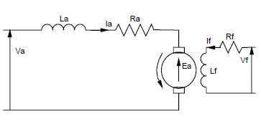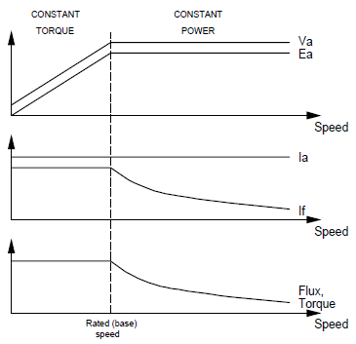
FIG 2.4 separately excited d.c motor FIG 2.5 d.c motor operating characteristics
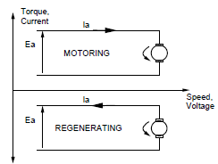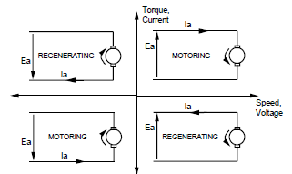
FIG 2.6a two quadrant operation FIG2.6b four quadrant operation
2.2.1 FOUR QUADRANT MOTOR OPERATIONS
If motoring and regenerating operation are required with both directions of rotation then the full bridge converter of FIG 2.7 is required. Using this configuration allows the polarity of the applied voltage to be reversed, thus reversing the direction of rotation of the motor. Thus in a full bridge converter the motor current and voltage can be controlled independently. The motor voltage Va is given by:
Va = V₁₂-V₃₄
Where V₁₂ is controlled by switching S1 and S2 as described above, and V₃₄ by switching S3 and S4, The usual operating mode for a full bridge converter is to group the switching devices so that S1 and S3 are always on simultaneously and that S2 and S4 are on simultaneously. This type of control is then referred to as bipolar control.
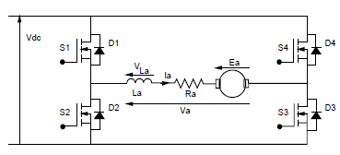
FIG 2.7 four quadrant full bridge circuit
2.3 CONSIDERATIONS FOR CONVERTER DRIVEN DC MOTORS
2.3.1 Device current rating
The power electronic converter must be matched to the requirements of the motor and the load. DC motor drives can be used to provide torques in excess of the maximum continuous rated torque of the motor for short intervals of time. This is due to the long thermal time constants of the motor. The peak torque requirement of the motor will determine its peak current demand, and hence the peak current requirement for the power switches. The current rating of a Power MOS device is limited by the maximum junction temperature of the device, which should not be exceeded even for short periods of time due to the short thermal time constant of the devices [9]. The devices must therefore be rated for this peak current condition of the drive. Operation at maximum current usually occurs during acceleration and deceleration periods necessary to meet the performance requirements of DC servo systems.
2.3.2 Device voltage rating
The voltage rating of the power switches will be determined by the power supply DC link voltage and the motor emfs, including those which occur when the motor is operating in its constant power region at above rated speed but below rated torque.

2.3.3 Motor performance
It can be seen from the waveforms the armature current supplied to the motor by the switching converter is not constant. The presence of ripple current in addition to the normal DC current affects the performance of the motor in the following ways:
- Torque pulsations. Ripple in the motor current waveform will cause a corresponding ripple in the motor output torque waveform. These torque pulsations may give rise to speed fluctuations unless they are damped out by the inertia of the mechanical system. The torque pulsations occur at high frequencies where they may lead to noise and vibration in the motor laminations and mechanical system [10].
- Losses. Winding losses in a DC motor are proportional to I_{RMS2}, whereas the torque developed by the motor is proportional to I_{DC}. Ripple in the motor current will increase the RMS current and armature resistance thus give rise to additional losses and reduce the system efficiency.
- Over currents. If the ripple current is large then the peak device current will be significantly higher than the design DC value. The devices must then be rated for this higher current. Current ripple will also increase the current which must be handled by the motor brushes possibly increasing arcing at the brush contacts.The amount of current ripple depends primarily upon the switching frequency and amount of motor inductance. Increasing La and fs will both reduce the amount of current ripple. The motor inductance is fixed by the motor selection but can be increased by the addition of a discrete component. Increasing the switching frequency of the system will reduce the amount of current ripple but will increase the switching losses in the power devices.

2.4 COMPARISON BETWEEN DC AND AC DRIVES
2.4.1 Motors:
- DC require maintenance, heavy, expensive, speed limited by mechanical construction
- AC less maintenance, light, cheaper, robust, high speed (esp. squirrel–cage type)
2.4.2 Control unit:
- DC drives: Simple control – decoupling torque and flux by mechanical commutator – the controller can be implemented using simple analog circuit even for high performance torque control –cheaper.
- AC drives, the types of controllers to be used depend on the required drive performance obviously, cost increases with performance. Scalar control drives technique does not require fast processor/DSP whereas in FOC or DTC drives, DSPs or fast processors are normally employed.
2.4.3 Performance:
- In DC motors, flux and torque components are always perpendicular to one another thanks to the mechanical commutator and brushes. The torque is controlled via the armature current while maintaining the field component constant. Fast torque and decouple control between flux and torque components can be achieved easily.
- In AC machines, in particular the induction machines, magnetic coupling between phases and between stator and rotor windings makes the modeling and torque control difficult and complex. Control of the steady state operating conditions is accomplished by controlling the magnitude and the frequency of the applied voltage; which is know
2.5 CONCEPT OF DIGITAL CONTROL DRIVES
As in all forms of industrial and precision control, digital implementations have replaced analogue circuitry in many electric drive systems, but there are few instances where this has resulted in any real change to the structure of existing drives, and in most cases understanding how the drive functions is still best approached in the first instance by studying the analogue version. There are of course important systems which are predominantly digital, such as PWM inverter drives and future drives that employ matrix converters may emerge and they are only possible using digital control [11]. But as far as understanding d.c. drives is concerned, users who have developed a sound understanding of how the analogue version operates will find little to trouble them when considering the digital equivalent.
Many drives use digital speed feedback, in which a pulse train generated from a shaft-mounted encoder is compared (using a phase locked loop) with a reference pulse train whose frequency corresponds to the desired speed. The reference frequency can easily be made accurate and drift-free; and noise in the encoder signal is easily rejected, so that very precise speed holding can be guaranteed [12]. This is especially important when a number of independent motors must all be driven at identical speed. Phase-locked loops are also used in the Wring-pulse synchronizing circuits to overcome the problems caused by noise on the mains waveform.
Digital controllers offer freedom from drift, added flexibility (e.g. programmable ramp-up, ramp-down, maximum and minimum speeds etc.), ease of interfacing and linking to other drives and host computers and controllers, and self-tuning. User-friendly diagnostics represents another benefit, providing the local or remote user with current and historical data on the state of all the key drive variables. Many of these advantages are also offered with drives that continue to employ analogue control in the power electronic stages.

2.6 CONCEPT OF PULSE WIDTH MODULATION (PWM)
Pulse-width modulation (PWM) is the basis for control in power electronics. The theoretically zero rise and fall time of an ideal PWM waveform represents a preferred way of driving modern semiconductor power devices. With the exception of some resonant converters, the vast majority of power electronic circuits are controlled by PWM signals of various forms. The rapid rising and falling edges ensure that the semiconductor power devices are turned on or turned off as fast as practically possible to minimize the switching transition time and the associated switching losses. Although other considerations, such as parasitic ringing and electromagnetic interference (EMI) emission, may impose an upper limit on the turn-on and turn-off speed in practical situations, the resulting finite rise and fall time can be ignored in the analysis of PWM signals and processes in most cases [13].
2.7 SPEED CONTROL - PWM TECHNIQUE
The motor is controlled by the 4 switches above. For the speed control explanation that follows only switches 1 and 4 will be considered because speed control is identical in the forward and reverse direction. Say the switches 1 and 4 are turned on, the motor will eventually run at full speed. Similarly if only switch 4 is turned on while switch 1 is off the motor stops. Using this system, how could the motor is run at 1/2 of the full speed? The answer is actually quite simple; turn switch 1 on for half the time and turn it off for the other half. In order to implement this system in reality, one must consider two main factors, namely frequency and duty cycle.
2.7.1 Frequency: Using the switch example, the frequency would be how fast the switch was turned on and off. If the frequency is too low (switch is changed slowly), then the motor will run at full speed when the switch is on, and completely stop when the switch is off. But if the frequency is too high, the switch may mechanically fail. In reality there is no switch, but rather an electronic board named an H-Bridge that switches the motor on and off. So in electrical terms; if the frequency is too low, the time constant of the motor has enough time to fully switch between on and off. Similarly the upper limit on the frequency is the limit that the H-Bridge board will support, analogous to the mechanical switch. The maximum frequency of this H-Bridge Board is 500 kHz, but the recommended frequency of the PWM for this board is 31.25 kHz [14].
2.7.2 Duty Cycle: The duty cycle is analogous to how long the upper switch (switch1) remains on as a percentage of the total switching time. In essence it is an average of how much power is being delivered to the motor. Duty cycle gives the proportional speed control of the motor. FIG 2.8 is an example of 1/4, 1/2, and 3/4 duty cycles. Effectively, these duty cycles would run the motor at 1/4, 1/2, and 3/4 of full speed respectively.
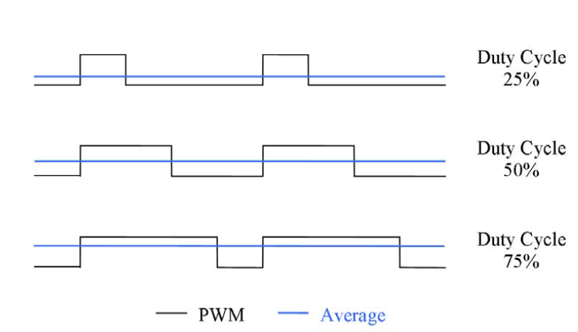
FIG 2.8 Pulse width modulated signal for d.c motor drive.

2.8 SPEED SENSOR MOTIONS

2.8.1 Optical sensor
From one to four channels can be implemented, each channel having a photo sensor that scans one of at most two signal tracks on a slotted disk. Experience shows that the possible number of channels achievable by this technique is still not enough. A number of subsystems therefore have to make do with looped-through signals from the wheel slide protection electronics and are therefore forced to accept, for instance, the available number of pulses, although a separate speed signal might well have some advantages. The use of optical sensors is widespread in industry. Unfortunately they do have two fundamental weaknesses that have always made it very difficult to get them to function reliably over a number of years, namely – the optical components are extremely susceptible to dirt, and – the light source ages too quickly [15]. Even traces of dirt greatly reduce the amount of light that passes through the lens and can cause signal dropout. These encoders are therefore required to be very well sealed. Further problems are encountered when the pulse generators are used in environments in which the dew point is passed: the lenses fog and the signal are frequently interrupted. The light sources used are light-emitting diodes (LEDs). But LEDs are always subject to aging, which over a few years leads to a noticeably reduced beam. Attempts are made to compensate for this by using special regulators that gradually increase the current through the LED, but unfortunately this further accelerates the aging process [16].

2.8.2 Magnetic sensor
The principle used in scanning a ferromagnetic measuring scale magnetically does not exhibit these deficiencies. During many years’ experience of using magnetic encoders there have been occasions when a seal has failed and a pulse generator has been found to be completely covered in a thick layer of brake dust and other dirt, but such pulse generators still functioned perfectly. Historically, magnetic sensor systems cost more than optical systems, but this difference is narrowing rapidly. Magnetic Hall and magneto resistive sensor systems can be imbedded in plastic or potting material, which increases mechanical reliability and eliminates damage from water and grease. Wheel speed sensors can also include hysteresis. This suppresses any extraneous pulses while the vehicle is at a standstill. Pulse generators constructed in accordance with this principle have been successfully field tested by several rail operators since the beginning of 2005 [17]. The type test specified in EN 5015 has also been successfully completed, so that these pulse generators can now be delivered
2.9 THE PIC MICROCONTROLLER
2.9.1 Microcontrollers versus Microprocessors
Microcontroller differs from a microprocessor in many ways. First and the most important is its functionality. In order for a microprocessor to be used, other components such as memory, or components for receiving and sending data must be added to it. In short that means that microprocessor is the very heart of the computer. On the other hand, microcontroller is designed to be all of that in one [18]. No other external components are needed for its application because all necessary peripherals are already built into it. Thus, we save the time and space needed to construct devices.
2.9.2 Memory unit
Memory is part of the microcontroller whose function is to store data. The easiest way to explain it is to describe it as one big closet with lots of drawers as shown in FIG 2.9. If we suppose that we marked the drawers in such a way that they cannot be confused, any of their contents will then be easily accessible. It is enough to know the designation of the drawer and so its contents will be known to us for sure.
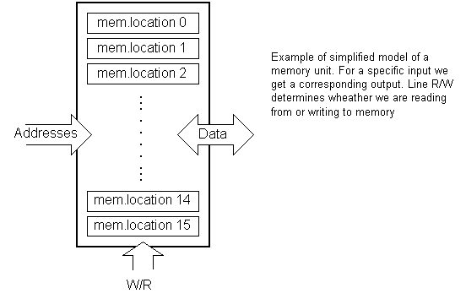
FIG 2.9 Example of a simplified memory unit
Memory components are exactly like that. For a certain input we get the contents of a certain addressed memory location and that's all. Two new concepts are brought to us: addressing and memory location. Memory consists of all memory locations, and addressing is nothing but selecting one of them. This means that we need to select the desired memory location on one hand, and on the other hand we need to wait for the contents of that location. Besides reading from a memory location, memory must also provide for writing onto it. This is done by supplying an additional line called control line. We will designate this line as R/W (read/write). Control line is used in the following way: if r/w=1, reading is done, and if opposite is true then writing is done on the memory location. Memory is the first element, and we need a few operation of our microcontroller [19].
2.9.3 Central Processing Unit
Let add 3 more memory locations to a specific block that will have a built in capability to multiply, divide, subtract, and move its contents from one memory location onto another as shown in FIG 2.10. The part we just added in is called "central processing unit" (CPU). Its memory locations are called registers.
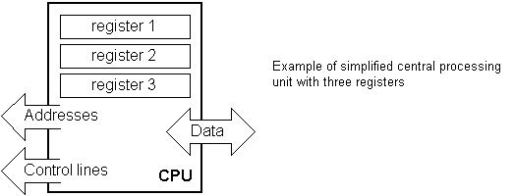
FIG 2.10 Diagram of simplified CPU with three registers
Registers are therefore memory locations whose role is to help with performing various mathematical operations or any other operations with data wherever data can be found. Look at the current situation. We have two independent entities (memory and CPU) which are interconnected, and thus any exchange of data is hindered, as well as its functionality. If, for example, we wish to add the contents of two memory locations and return the result again back to memory, we would need a connection between memory and CPU. Simply stated, we must have some "way" through data goes from one block to another.
2.9.4 Bus
That "way" is called "bus". Physically, it represents a group of 8, 16, or more wires; there are two types of buses: address and data bus as shown in FIG 2.11. The first one consists of as many lines as the amount of memory we wish to address and the other one is as wide as data, in our case 8 bits or the connection line. First one serves to transmit address from CPU memory, and the second to connect all blocks inside the microcontroller.
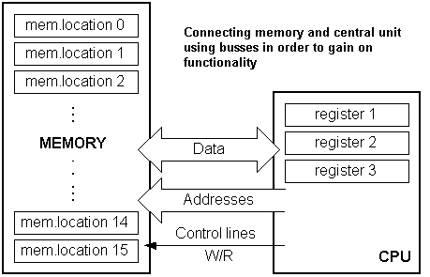
FIG 2.11 Diagram of connection between memory and central unit using busses
As far as functionality, the situation has improved, but a new problem has also appeared: we have a unit that's capable of working by itself, but which does not have any contact with the outside world, or with us! In order to remove this deficiency, let's add a block which contains several memory locations whose one end is connected to the data bus, and the other has connection with the output lines on the microcontroller which can be seen as pins on the electronic component.
2.9.5 Input-output unit
Those locations we've just added are called "ports". There are several types of ports: input, output or bidirectional ports as shown in FIG 12. When working with ports, first of all it is necessary to choose which port we need to work with, and then to send data to, or take it from the port.
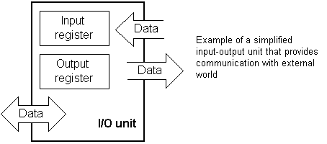
FIG 2.12 Example of a simplified input-output unit providing communication
When working with it the port acts like a memory location. Something is simply being written into or read from it, and it could be noticed on the pins of the microcontroller.
2.9.6 Serial communication
Beside stated above we've added to the already existing unit the possibility of communication with an outside world. However, this way of communicating has its drawbacks. One of the basic drawbacks is the number of lines which need to be used in order to transfer data. What if it is being transferred to a distance of several kilometers? The number of lines times’ number of kilometers doesn't promise the economy of the project. It leaves us having to reduce the number of lines in such a way that we don't lessen its functionality. Suppose we are working with three lines only, and that one line is used for sending data, other for receiving, and the third one is used as a reference line for both the input and the output side. In order for this to work, we need to set the rules of exchange of data. These rules are called protocol. Protocol is therefore defined in advance so there wouldn't be any misunderstanding between the sides that are communicating with each other. For example, if one man is speaking in French, and the other in English, it is highly unlikely that they will quickly and effectively understand each other. Let's suppose we have the following protocol. The logical unit "1" is set up on the transmitting line until transfer begins. Once the transfer starts, we lower the transmission line to logical "0" for a period of time (which we will designate as T), so the receiving side will know that it is receiving data, and so it will activate its mechanism for reception. Let's go back now to the transmission side and start putting logic zeros and ones onto the transmitter line in the order from a bit of the lowest value to a bit of the highest value. Let each bit stay on line for a time period which is equal to T, and in the end, or after the 8th bit, let us bring the logical unit "1" back on the line which will mark the end of the transmission of one data. The protocol we've just described is called in professional literature NRZ (Non-Return to Zero).
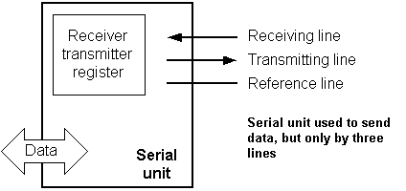
FIG 2.13 A serial unit used to send data
As we have separate lines for receiving and sending, it is possible to receive and send data (info.) at the same time. So called full-duplex mode block which enables this way of communication is called a serial communication block. Unlike the parallel transmission, data moves here bit by bit, or in a series of bits what defines the term serial communication comes from. After the reception of data we need to read it from the receiving location and store it in memory as opposed to sending where the process is reversed. Data goes from memory through the bus to the sending location, and then to the receiving unit according to the protocol. This is shown above in FIG 2.13
2.9.7 Timer unit
Since we have the serial communication explained, we can receive, send and process data.
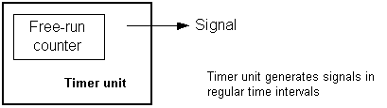
FIG 2.14 A timer unit
However, in order to utilize it in industry we need a few additionally blocks. One of those is the timer block which is significant to us because it can give us information about time, duration, protocol etc like in FIG 2.14. The basic unit of the timer is a free-run counter which is in fact a register whose numeric value increments by one in even intervals, so that by taking its value during periods T1 and T2 and on the basis of their difference we can determine how much time has elapsed. This is a very important part of the microcontroller whose understanding requires most of our time.

2.9.8 Watchdog
One more thing is requiring our attention is a flawless functioning of the microcontroller
during its run-time. Suppose that as a result of some interference (which often does occur in industry) our microcontroller stops executing the program, or worse, it starts working incorrectly.
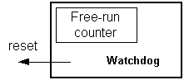
FIG 2.15 a watchdog
Of course, when this happens with a computer, we simply reset it and it will keep working. However, there is no reset button we can push on the microcontroller and thus solve our problem. To overcome this obstacle, we need to introduce one more block called watchdog. This block is in fact another free-run counter where our program needs to write a zero in every time it executes correctly. In case that program gets "stuck", zero will not be written in and counter alone will reset the microcontroller upon achieving its maximum value. This will result in executing the program again, and correctly this time around. That is an important element of every program to be reliable without man's supervision. This is shown above in FIG 2.15
2.9.9 Analog to Digital Converter
As the peripheral signals usually are substantially different from the ones that microcontroller can understand (zero and one), they have to be converted into a pattern which can be comprehended by a microcontroller. This task is performed by a block for analog to digital conversion or by an ADC like in FIG 2.16a. This block is responsible for converting an information about some analog value to a binary number and for follow it through to a CPU block so that CPU block can further process it.
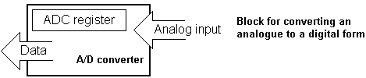
FIG 2.16a diagram of a block from an analogue to a digital form
Finally, the microcontroller is now completed, and all we need to do now is to assemble it into an electronic component where it will access inner blocks through the outside pins. The picture below in FIG 2.16b shows what a microcontroller looks like inside.
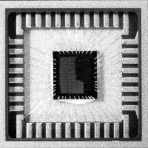
FIG 2.16b Physical configuration of the interior of a microcontroller
Thin lines which lead from the center towards the sides of the microcontroller represent wires connecting inner blocks with the pins on the housing of the microcontroller so called bonding lines. Chart on the following page in FIG 2.17 represents the center section of a microcontroller.
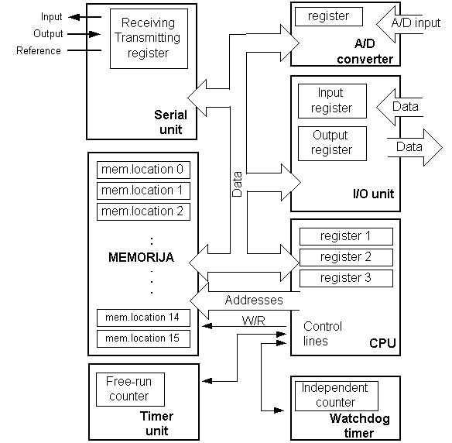
FIG 2.17 Microcontroller outline with its basic elements and internal connections
For a real application, a microcontroller alone is not enough. Beside a microcontroller, we need a program that would be executed, and a few more elements which make up a interface logic towards the elements of regulation.
CHAPTER THREE
SYSTEM DESIGN
3.0 INTRODUCTION
To solve a problem in Engineering certain algorithms are laid down which defines the possible way of reaching the solution to the problem at hand. In this chapter the step by step procedure used to achieve the aim of this project will be listed. In this project the following steps were taken;
- Block diagram drafting
- Design of the power supply circuit.
- Configuration of the microcontroller and interfacing with the LCD
- Designing the MOSFET driver
- Programming the microcontroller
- Drawing and Simulating the circuit
- Circuit principle of operation

3.1 BLOCK DIAGRAM REPRESENTATION OF THE SYSTEM

12VDC PWM
12VDC PWM
5VDC PWM
5VDC
12VDC
12VDC
Power supply
+5v & +12v
PIC microcontroller
LCD
DISPLAY
(RPM, REF. INPUT)
MOSFET DRIVER
DRIVING MOSFET
MOTOR SPEED
SENSOR
MOTOR
5VDC

FIG 3.1 Block diagram of the design.

3.2 SPECIFIC SPECIFICATIONS
There specifications required in order to design a good power supply circuit, this specifications are made in line with the obtainable power source and the required outputs. The design specifications of the power supply for this project is given below.
Design parameter | Specification
Input voltage | 220-240Vac
Frequency | 50Hz
Input current | 1A
Output voltage(s) | 5Vdc and 12Vac
Output current | 1A

3.3 SYSTEM DEVELOPMENT
3.3.1 THE POWER SUPPLY UNIT
Looking at the specifications, the design of a d.c power supply involves four stages which are;
- Transformation stage
- Rectification stage
- Filtering stage
- Regulation stage

3.3.1.1 Transformation stage:
This is the first stage of d.c power supply deign. At this stage the input voltage from the AC source is being stepped down to the maximum range of the desired d.c output voltage. This transformation is done with the use of and inductive component know as a “Transformer”.
A transformer is used to step up or down AC voltage. It comprises of a primary and secondary windings which are not electrically connected but works by electromagnetic induction to step up or down voltages with respect to the numbers of turns making up the primary and secondary windings [20].
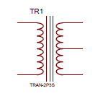
FIG 3.2 Transformer winding.
In this project the transformer used is rated 220-240/12 Vac, 50Hz and 1A as the input voltage/output voltage, frequency and current respectively. The diagram of a transformer is shown above in FIG 3.2
3.3.1.2 Rectification stage
This is the immediate stage after the input Vac has been transformed (stepped down). The rectification stage is needed since we want to achieve a dc power supply. The rectification stage helps to convert the already stepped down ac to d.c voltage. In this project we used a full bridge rectifier to achieve a full rectification. What is a bridge rectifier? A bridge rectifier is a device that converts AC from a transformer into pulses of DC voltage like show in FIG 3.3.
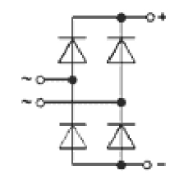
FIG 3.3 diode bridge rectifier
In the design assurance was made that the bridge rectifier used can withstand the current rated in the specifications table above.
3.3.1.3 Filtering stage:
After rectifying the AC voltage from the transformer the d.c obtained is needed to be smoothened or filtered of the higher harmonics that might be harmful to the device to be supplied with the d.c supply. To achieve smoothening capacitors are connected in parallel with the bridge rectifier. The capacitor is made of high capacitance to ensure a good smoothening and also the voltage rating of the capacitor is made to be much higher than the Vdc output after the bridge rectifier. The Vdc output after the rectifier is given as
$$Vdc=\sqrt{2}×Vac$$
In this project a 220-240/12Vac was used and thus the Vdc was calculated to be 16.9705627Vd and thus the capacitor rating used is 3300uf/25V.

3.3.1.4 Regulation stage:
This stage is the last stage of the design and the most important stage in power supply design since it’s the stage at which the voltage is regulated to the required output. To regulate voltage regulator ICs are used such as Lm317, 78 series (for positive voltage output) and 79 series (for negative voltage output). In this project we made use of regulator IC 7805 for the positive 5V and IC7812 for positive 12V output. This is shown below in FIG 3.4.

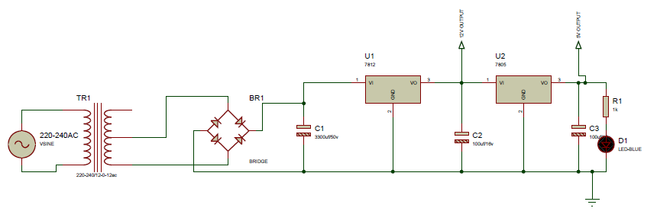
FIG 3.4 power supply circuit diagram

3.3.2 THE MICROCONTROLLER:
A microcontroller (sometimes abbreviated μC, uC, or MCU) is a small computer on a single integrated circuit containing a processor core, memory, and programmable input/output peripherals. The Program memory in the form of NOR flash or OTP ROM is also often included on chip, as well as a typically small amount of RAM. Microcontrollers are designed for embedded applications. Microcontrollers are used in automatically controlled products and devices, such as automobile engine control systems, implantable medical devices, remote controls, office machines, appliances, power tools, and other systems [21].
3.3.2.1 PWM signal generation from the microcontroller
The capture, compare and PWM module was used to generate a 5 kHz frequency PWM for driving the motor. This was achieved by the use of a compiler known as Mikroc. Mikroc is a compiler for programming microcontrollers using C language. This compiler has an inbuilt library from which a subroutine can be called. The compiler has a an inbuilt subroutine for initializing the PWM (PWM_Init(freq in khz)) , setting the duty cycle (PWM1_Set_Duty(192)), starting the PWM (PWM1_Start()) and stopping the PWM(PWM1_Stop()) . With this subroutines the microcontroller was meant to generate the 5khz pulse width modulated signal with variable duty cycle via the CCP2 the 16th pin of the microcontroller.
3.3.3 THE ALPHANUMERIC LCD.
An alphanumeric LCD shown below in FIG 3.5 is a type of LCDs that only displays English letters, numbers and some ASCII characters, those LCDs contains a controller unit that processes the input and forms the displayed character on the LCD, most alphanumeric LCDs have a parallel interface; some other LCDs have a serial interface to minimize the construction complicity.
Alphanumeric LCDs comes in different sizes, the size describes the number of characters an LCD can display, common sizes are 16x2, 20x2, 16x4, 20x4...Etc. a 16x2 has 2 rows and can display 16 characters on each row.
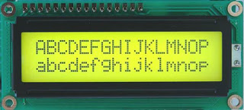
FIG 3.5 16x2 liquid crystal display

Parallel LCD Pinout:
Parallel LCDs typically have 16 pins as following:
- Power Supply Pins:
Vss : Ground reference (0V)
Vcc : +5V supply voltage
Vee : Contrast pin, typically connected to GND via a resistor (0Ω - 5kΩ), change the value to change the contrast.
- Control Bus Pins:
RS : Register Select, used to set the LCD either to command mode or to data mode.
R/W : Read/Write select, used either to read characters from LCD or to write new characters.
E : Active low Enable signal.
- Data Bus Pins:
D0-D7: used to pass 8Bit character data, you have the choice either to use only 4Bit bus (D4-D7) or to use the whole data bus.
- Backlight Voltage Pins:
A : Anode (+5V)
K : Cathode (0V)
Used to turn ON/OFF the backlight LED of your LCD.
3.3.3.1 The alphanumeric interfacing with the microcontroller
In this project a 20x4 LCD was used. The LCD has same pin-out configuration as shown above. The LCD was interfaced with the microcontroller using 4bit interfacing configuration. The compiler also has subroutines and commands for interfacing an LCD in its library. In writing the program, first of all the LCD is being configured via the compiler in the program. The configuration entails describing the pin-out of the LCD and its direction to the microcontroller to enable the microcontroller determine the pins with which the pin-out of the LCD is connected to. Configuring the LCD in the 4bit mode the data pins of the LCD D0-D3 are not used or better sent to ground while data pins D4-D7,the enable pin (E ) and reset pin (Rs) are used to interface with the microcontroller. Other pins R/W, Vss, Vee, and Vdd are connected to ground, ground, contrast pin and Vcc(+5v) respectively.
3.3.4 The Mosfet driver circuit configuration
Since the microcontroller produces an output PWM of +5V amplitude at a current of 400mA it cannot be used to supply the pulse directly to drive the motor or the mosfet thus the need for a mosfet driver with which the mosfet can be driven to full saturation so as to provide the motor with enough current.
The mosfet driver circuit used in this project consist of two bipolar junction transistors (NPN and PNP) the transistors are BC547 and BC557. The circuit is as shown below in FIG 3.6
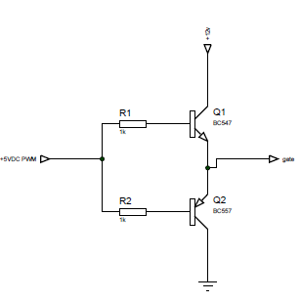
FIG 3.6 circuit diagram of a mosfet driver
The 5 Vdc pulse width modulated signal generated by the microcontroller is used to turn the mosfet drivers on through a 1k ohm resistors as a current limiter, connected at the base of the adjacent transistors. The driver when turned on sources the 12Vdc from the power at a higher current to fully turn on the gate of the mosfet.
3.3.5 The Mosfet
The switch to be used here is a Metal Oxide Semiconductor Field Effect Transistor, or MOSFET. Mosfets come in two polarities called N and P channel. The one to be used here is an N channel device. A schematic representation and a picture showing the pin designations is shown below in FIG 3.7 (the sunflower is almost never included). Notice that the Drain is also connected to the metal tab, making it necessary to insulate the mosfet when using a heat sink:

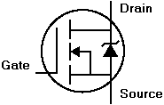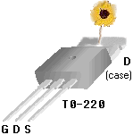
FIG 3.7 diagram of a mosfet
Enhancement mode N channel mosfet is turned on by making the gate more positive than the source. What is enhanced is the conductivity between source and drain.
Here we will use particularly IRF3205, a power mosfet designed with the following properties
R_{DS(on)} = 8.0mohm, I_{D} = 110A, V_{DSS} = 55V, fast switching and full avalanche rated.

3.3.6 The mosfet driving circuit
Since the motor cannot be driven directly from the microcontroller we used a mosfet with a fast switching characteristics like that described above. The mosfet is been driven by the mosfet driver circuit below in FIG 3.8 which ensures that the mosfet fully turns on so as to reduce the drain-source resistance of the mosfet(R_{ds}). The configuration of the of the mosfet driving circuit is as shown below
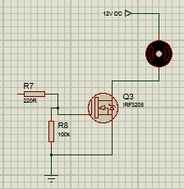
FIG 3.8 The motor driving circuit
The 12vdc PWM signal from the mosfet driver is fed into the gate of the mosfet through the 220 ohm resistor to fully turn on the mosfet in other to drive the motor. The 100k resistor connects between the gate and source of the mosfet is meant to ensure that the motor turns off during the time off of the signal from the PWM.
3.3.7 The motor speed sensing technique
In this project the motor speed sensor used is an optical motor speed sensor made up of a phototransistor and a light emitting diode placed in a plastic casing and made to face each other shown in FIG 3.9a and 3.9b. A phototransistor in the absence of light has a very large resistance between the collector and emitter making it impossible for current to pass through it but on incident of light the resistance reduces to an approximate little or no resistance allowing current flow from the collector to emitter.
This behavior was employed in sensing the speed of a motor by attaching fan blade on the motor. The sensor was attached across the blade in such a way that the light emitting diode stands opposite the phototransistor and the blade in between them. As the motor rotates and the sensor is powered, the blades of the fan causes interruption of the infrared light thus making the sensor emit pulses with respect to the rate of the light interruption.
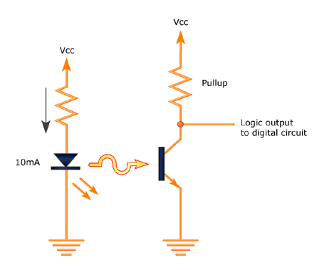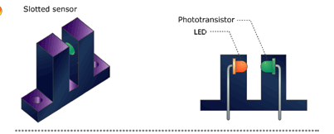
FIG 3.9a Optical speed sensor circuit. FIG 3.9b physical diagram of the optical sensor
In the circuit above the series resistance with the photodiode was set to 100 ohms as a current limiter. A 100k ohm variable resistor was use as the pull-up resistor to the collector of the phototransistor with which the sensitivity was adjusted to fit the sensing purpose for efficient operation.
3.3.8 PROGRAMMING THE MICROCONTROLLER
The microcontroller was programmed using a compiler known as Mikroc produced by microchip technology. This compiler is meant for programming in c language. The compiler is built with libraries that makes it easy to interact and make use of the peripherals of the microcontrollers among its library are the LCD, library, PWM library and the button library. These libraries made it easy to interface the LCD and the pushbutton with the microcontroller. The program flow chart is shown below in FIG 3.10;

Set RPM_{ref} START PWM
Sense speed

Adjust the PWM duty cycle
wait
START
Declare variables
Configure interface I/opin inputpinspins
Speed = RPMref
NO
YES

FIG 3.10 Program flow diagram

The program starts with declaring variables and configuring the microcontroller to recognize the pin locations of the interfaced LCD. This was done by the use of the pin configuration command as follows;
sbit LCD_RS at RB4_bit;
sbit LCD_EN at RB5_bit;
sbit LCD_D4 at RB0_bit;
sbit LCD_D5 at RB1_bit;
sbit LCD_D6 at RB2_bit;
sbit LCD_D7 at RB3_bit;

sbit LCD_RS_Direction at TRISB4_bit;
sbit LCD_EN_Direction at TRISB5_bit;
sbit LCD_D4_Direction at TRISB0_bit;
sbit LCD_D5_Direction at TRISB1_bit;
sbit LCD_D6_Direction at TRISB2_bit;
sbit LCD_D7_Direction at TRISB3_bit;

in the program each pin of the microcontroller is set and directed to a pin-out of the LCD.
The next part of the program was to set the ports of the microcontroller as input or ouput port with respect to their different functions. The PORTA was set as input port from which the sensor were interfaced while PORTB and some part of PORTC was set as output pins from which the LCD and the PWM signal were interfaced and generated respectively. In setting the port the following code were used;
TRISA = 0XFF; TRISB = 0X00; TRISC =0X07;
The TRIS register in the microcontroller is a register used to declare a pin as output or input. This microcontroller comprises of three TRIS register which comprises of TRISA, TRISB, and TRISC corresponding to the three ports of the microcontroller.
The special functions, LCD functions and PWM functions was initialized by calling the command Lcd_Init() and PWM1_Init(5000); this command calls from the library the program routine that gets the microcontroller ready to accept or execute any command from the interfaced device.
After the initializations the button press routine for setting the reference speed, were written and the PWM was started. When the PWM starts a 5kz frequency with a gradual varying duty cycle is generated at pin 12 of the microcontroller which is fed to the motor via mosfets and mosfet driver. The program enters a loop where the speed is continuously sensed through the optical speed sensor and is calculated and compared with the reference speed until the motor reaches the set reference speed. The circuit diagram of the project is shown below in FIG 3.11.
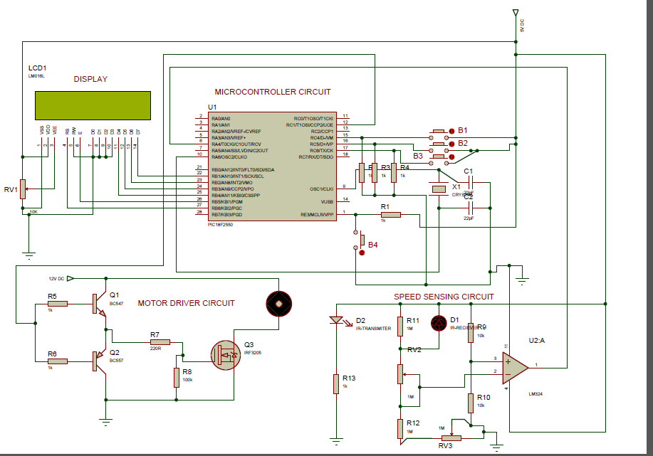
FIG 3.11 Design circuit diagram

3.3.9 PRINCIPLE OF OPERATIONS OF THE CIRCUIT:
The circuit is implemented to control the speed of a 12v DC motor with respect to the reference speed input by the user. The speed is regulated not to go above or below the reference speed input by sensing the speed of the motor once started and comparing with the reference speed.
In the circuit of fig3.10 above the microcontroller IC1 is used to generate the PWM signal with variable duty cycle for driving the motor. The signal once generated is fed to the mosfet driver which outputs 12v DC PWM that is fed to the mosfet and the mosfet in turn drives the motor.
The speed sensor senses the speed by sending out pulses caused by interruption of the light between the infrared transmitter and receiver by the three fan blade attached to the motor. This pulse generated is sent back to the microcontroller through pin4. The microcontroller picks it up and calculates the speed in RPM using the formulae RPM = (256*(TMR0H+TMR0L) *60)/3. This was achieved by triggering the TMR0 of the microcontroller and making it record the pulses at every one second delay and reading the value of TMR0H and TMR0L in 8bit. The value read is multiplied by 60 to convert to RPM and then divided with the number of blade used on the motor (3).
The speed calculated is compared with the reference speed, if less the duty cycle percentage of the PWM driving the motor automatically increases to increase the speed but if the speed is more than the reference input the PWM duty cycle percentage is reduced to match the reference speed thus keeping the motor at a constant speed irrespective of the load it is driving.
3.4 S0FTWARE DEVELOPMENT
The software part of the work was the programming of the microcontroller to achieve the calculated the speed from the pulses fed in by the speed sensor, to generate a PWM signal for driving the motor and to accept input speed and compare with the speed of the motor. The program was written in C language using a compiler known as mikroc for PIC. The programme is as shown bellow;
unsigned long RPM_Value;
intdigit1[] = {50,100,150,200,250,300,350,400,450,500,550,600,650,700,750,800,850,900,950,1000,1050,1100,1150,1200,1250,1300,1350,1400,1450,1500,1550,1600,1650,1700,1750,1800,1850,1900,2000};
char count1[15]; //declearing variables
int value,i;
int oldstate,duty;
// Define LCD module connections.
sbit LCD_RS at RB6_bit;
sbit LCD_EN at RB5_bit;
sbit LCD_D4 at RB4_bit;
sbit LCD_D5 at RB3_bit;
sbit LCD_D6 at RB2_bit;
sbit LCD_D7 at RB1_bit;
sbit LCD_RS_Direction at TRISB6_bit;
sbit LCD_EN_Direction at TRISB5_bit;
sbit LCD_D4_Direction at TRISB4_bit;
sbit LCD_D5_Direction at TRISB3_bit;
sbit LCD_D6_Direction at TRISB2_bit;
sbit LCD_D7_Direction at TRISB1_bit;
// End LCD module connection definition
sbit IR_Tx at RA3_bit;

// Define Messages
char message1[] = "CHOOSE SPEED LEVEL";// message to display at start up
char *RPM = "00000 RPM";
void Display_RPM(unsigned long num){ // bit by bit display of speed value on LCD
RPM[0] = num/10000 + 48;
RPM[1] = (num/1000)%10 + 48;
RPM[2] = (num/100)%10 + 48;
RPM[3] = (num/10)%10 + 48;
RPM[4] = num%10 + 48;
Lcd_out(1,3,"MOTOR RUNNING AT"); //
Lcd_Out(3,5,RPM);
}

void main() {
CMCON = 0x07; // Disable comparators
ADCON1 = 0x0F; // Disable Analog functions
TRISC = 0xFF;
TRISB = 0x00;
PORTA = 0x00;
TRISA = 0b00010000;
T0CON = 0b01101000; // TMR0 as 16-bit counter
PWM2_Init(5000);
duty = 0;
oldstate = 0;
i = 0;
Lcd_Init(); // Initialize LCD
Lcd_Cmd(_LCD_CLEAR); // CLEAR display
Lcd_Cmd(_LCD_CURSOR_OFF); // Cursor off
Lcd_Out(1,2,message1);
Lcd_out(4,1,"B1++");
Lcd_out(4,6,"B2--");
Lcd_out(4,12,"B3 ENTER");
// Write message1 in 1st row
while(PORTC.F6 == 0){
if (Button(&PORTC, 4, 1, 1) ) { // Detect logical one
i++;
value = digit1[i]*1;
wordToStr(value,count1);
Lcd_Out(3,5,count1);
Lcd_out(3,12,"RPM");
delay_ms(200); }
if (Button(&PORTC, 5, 1,1 )) { // Detect one-to-zero transition
i = i-1;
value = digit1[i]*1;
wordToStr(value,count1);
Lcd_Out(3,5,count1);
Lcd_out(3,12,"RPM");
delay_ms(200); }
}
do { //endless loop
Lcd_cmd(_LCD_CLEAR);
while(RPM_Value!=digit1[i]){
if(RPM_Value < digit1[i]){ duty = duty+10;}
else if(RPM_Value > digit1[i]){duty = duty-10;}
PWM2_Set_duty(duty);
PWM2_Start();
T0CON.TMR0ON = 1;
TMR0L = 0;
TMR0H = 0;
IR_Tx = 1;
Delay_ms(1000); // Wait for 1 sec
IR_Tx = 0;
T0CON.TMR0ON = 0; // Stop the timer
RPM_Value = ((256*TMR0H + TMR0L)*60)/3;
Display_RPM(RPM_Value);

}
} while(1); // Infinite Loop
}//end of programme.
After the programme was written it was burnt into the chip using a programmer known as pickit. The chip was plugged into the circuit and was powered. The circuit tested ok and the motor ran at the reference speed for a while before it was powered off. The circuit is packaged into a transparent casing made of Perspex board.

CHAPTER FOUR

4.0 CONSTRUCTION, TESTING AND RESULTS
Having done all the necessary research and obtained the necessary materials and required method with which the goal of this project was achieved. The constructions carried out and in this chapter will be discussed in parts and in detail.
  - CONSTRUCTION
The construction comprises of implementing the entire circuit diagram as simulated in the software using the physical. It also concerns the packaging of the work into a portable designed casing. The hardware part was subdivided into different parts which are;
- The power supply circuit.
- Microcontroller configuration and interfacing.
- Motor driver construction.
- Motor speed driver configuration.
4.1.1 The Power supply circuit
The power supply circuit was implemented based on the design specification and circuit in chapter three. Here the transformer T1 is a centre tapped transformer rated 220-240/12-0-12Vac. This was connected to step down the voltage and the a bridge rectifier BR1 was connect across the transformer stepped down output via the middle two pins marked “ac” while the two legs at both edge marked + and – corresponded to the DC rectified output VCC and GND. A 2200uf/50v capacitor C1 was connected across the + and – of the rectified output after which the positive pin of C1 was connected to the pin 1 of 12volts regulator U1 with pin2 connected to the negative pin of C1. From pin3 of U1 a 12volt dc output with capacitor 100uf/16v C2 connected across was fed into 5volts regulator U2 through its pin1 and pin2 connected to VCC and GND respectively. The output with capacitor C3 100uf/16v was connected across it. An indicator light was connected with a 10k resistor as current limiter to prevent the LED from burning.
4.1.2 Microcontroller configurations and interfacing
Configuring the microcontroller simply means to set the microcontroller to the required working mode. Here we used PIC18F2550 from the PIC18 family. The pinout diagram is as shown below in FIG 4.1;
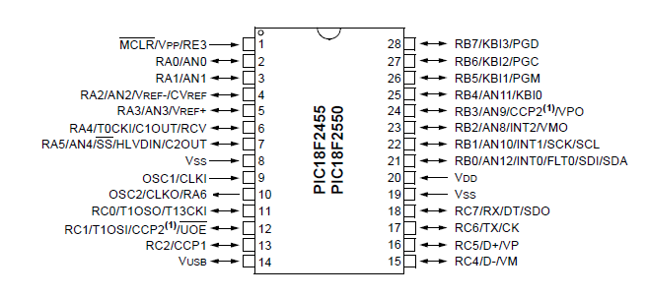
FIG 4.1 Pin-out diagram of PIC18F2550

To configure the microcontroller first the pin 19(vss) and 8(vss) of fig4.1 is connected together and sent to the GND. Then the pin 20(vdd) is connected to the input 5v dc power supply. The pin1 was then connected to Vcc through a 1k (R1) pull-up resistor since it’s a low active input, then a push button B4 connected across pin1 and ground for resetting the microcontroller. A 4 MHz crystal oscillator X1 is connected across the pin 9and 10 with two 22pf capacitors C1 and C2 connected across 9 and 10 respectively to GND. With the above connections made, the microcontroller is set to operate fully. The interface devices; LCD, pushbutton, speed sensor interface and the PWM output were configured through the input/output pin of the microcontroller. For LCD interfacing the pin-out of the LCD; RS,EN,D4,D5,D6,D7 were connected to pins 27,26,25,24,23,22 of the microcontroller while the rest of the pins of the LCD Vss to Gnd,Vdd to Vcc,V0 to potentiometer RV1 for contrast, D0,D1,D2,D3 connected to GND, and finally pins A and K to 5V and GND through a 1k resistor.
The pushbuttons B1, B2, B3 were connected to pins 15, 16, 17 of the microcontroller respectively with pull-down 10k resistors R2, R3, R4. The speed sensor output is connected as input to the microcontroller through the pin 6 of the microcontroller. While the PWM output from the microcontroller is at pin 12 of the microcontroller to the motor driver is connect. The circuit is as shown below in FIG 4.2;
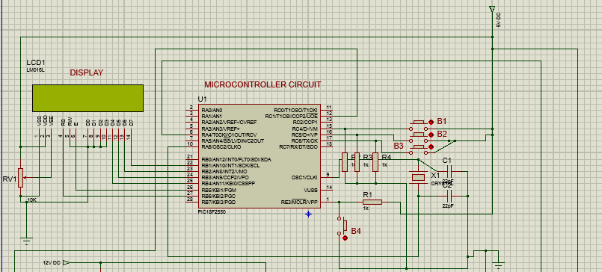
FIG 4.2 Microcontroller interface diagram

4.1.3 Motor driver construction
To drive the motor two circuits were put together so as to provide the motor with enough power, since it’s not possible to drive the motor directly from the microcontroller. The following circuit in FIG 4.3 drives the motor;
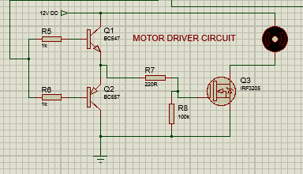
FIG 4.3 Motor driver circuit diagram.
The BJT transistors Q1 (BC547 NPN) and Q2(BC557PNP) are connected Emitter to Emitter while the collector of Q1 is connected to 12V dc supply for driving the mosfet. The collector of Q2 is connected to GND. The base of the two transistors is connected to the PWM output of the microcontroller through 1k resistors R5 and R6 respectively. The mosfet Q3 with heat sink attached at the back to avoid over heating has its gate connected at the ouput of the mosfet driver through R7 a 220 ohm resistor and also a 100k resistor connect between the gate to GND to make sure the mosfet is fully off during off mode. Then the motor is connected between 12V dc and the drain of the mosfet Q3 and then the source connected to ground.

4.1.4 Motor speed sensor configuration.
The motor speed sensor comprising of an infrared receiver and transmitter this works on the principle of light interruption and was configured using a comparator with high value resistors connected as shown in the circuit below in FIG 4.4;
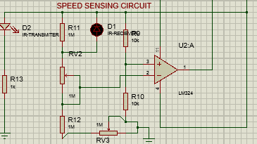
FIG 4.4 Motor speed sensing circuit.

4.2 TESTING AND RESULTS
After the connection the power supply was powered and the two separate outputs were read with a voltmeter. The 12V output read 11.89V and the 5V read 4.98V. With the result of the measured value the power supply was checked and marked successful. The lm324 U2:A is biased by connecting the pin 11 to GND and the pin 4 to 5v dc, then the 5v dc is divided between two 10k resistor to set the reference voltage at the non inverting input of the op-amp pin 3 while the infrared receiver is connected in reverse bias mode with a 1M ohm resistor in parallel an 1M variable in series and connected in a voltage divider mode with 1M ohm resistor and 1M ohm variable resistor at pin 2 the inverting pin of the op-amp. This connection is to monitor the varying intensity of light falling on the infrared receiver. After connecting it the variable resistors were varied to make the op-amp output positive output when the light from the infrared transmitter is interrupted. It was tested first with an LED bulb and a positive output was recorded at every slight interruption making it suitable for the speed sensing. A diagram of the completed circuit is show below in FIG 4.5

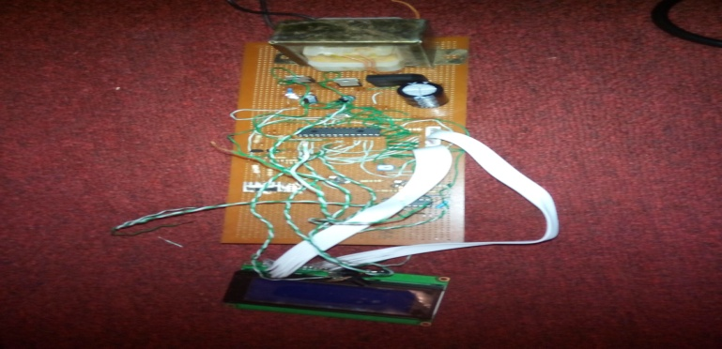

FIG 4.5 diagram of the soldered work front view

4.2.1 CHALLENGES AND SOLUTIONS
- The first challenge encountered in this work was the mode of sensing the speed of the motor. We tried to sense the speed of the motor using the back emf produced by the motor but found out that it was not accurate unless the system is interfaced with a personal computer where the back emf would be monitored and thus the speed relation obtained. Finally we learnt that we can read in pulses as a result of light interruption mechanism by using an optical device and connecting a small fan blade that will interrupt the light at every rotation thereby producing pulses with which the speed was calculated from.
- The other challenge we encountered was getting the materials for the implementation which we had to travel to some cities in Nigeria to buy.
4.3 LIMITATIONS OF THE DESIGN
- The design will work well for motor with current ratings less than 1A
- The motor to be controlled will break down if overloaded since the system will try to get it running at the reference speed.
- The design can only control a dc motor in one direction.
- The design can only control a 12V dc motor.

CHAPTER FIVE
COST ANALYSIS, CONCLUSION AND RECOMMENDATIONS

5.1 COST ANALYSIS
S/N | COMPONENTS | QTY | COST(#)
1 | Transformer | 1 | 500
2 | 2200uf/50v | 1 | 100
3 | 100uf/16v | 2 | 200
4 | 7812 regulator | 1 | 150
5 | 7805 | 1 | 150
6 | 1k ohms | 4 | 30
7 | 10k ohms | 5 | 50
8 | 100k ohms | 1 | 10
9 | PIC18F2550 | 1 | 1500
10 | MOSFET | 1 | 150
11 | BC547 | 1 | 100
12 | BC557 | 1 | 100
13 | Pushbuttons | 4 | 400
14 | 4mhz Xtal | 1 | 300
15 | Speed sensor | 1 | 1500
16 | 40 pins Socket | 1 | 100
17 | 8pins connectors | 2 | 200
18 | Dc motor | 1 | 5000
19 | 1N4001 | 1 | 50
20 | Bridge rectifier | 1 | 150
21 | Plug | 3 | 500
22 | Switch | 1 | 100
Total 36 |  |  | 11340

5.2 CONCLUSION
The art of design and construction is based on the solution to a problem the engineer aimed to solve. The design of a digital motor speed control which is aimed at solving the problem of over speed and under speed. This brought in view the behaviour of dc motor in the presence of varying levels of current input to the motor. The knowledge of the relationship between current and torque generated in the motor made it possible to control the speed of the motor with varying current flow into the motor. Also by generating a pulse width modulated signal with varying duty cycle which serves as the bedrock of digital control of switching devices like mosfet the current flow into the motor was controlled and a required speed was obtain by simply adjusting the duty cycle of the PWM generated. In sensing the speed an optical sensor with a fast switching ability we were able to keep track of the speed of the motor through the pulse the speed sensor emits and the fed back to the microcontroller with the features that enables it to record the pulses and is able to calculate the speed with the help of a programme written to it.
With the above the speed was able to be sensed, calculated, compared and controlled automatically. With the circuit designed implemented tested and used, it proves that the motor speed can be controlled digitally by use of PWM with variable duty cycle. Also the sensing ability of infrared transmitter and receiver was proved to an extent since it was able to detect interruption at a high speed. The programmed digital motor speed control system proved to be more cost effective and easy to implement despite the challenges and limitations encountered in this work.

5.3 RECOMMENDATIONS
In choosing microcontroller for constructing this work it is recommended that the engineer should choose a microcontroller that has more output pins in the PIC18 family order than PIC18F2550 used in this project. For the speed sensing a better sensor than the optical sensor would be better off since the on time of the optical sensor limits it from measuring a very high speed if need be. Finally a better speed control would be best achieved if the system is interfaced with a personal computer where the signal response will be monitored and the speed control would be more precise.

Appendix
unsigned long RPM_Value;
intdigit1[] = {50,100,150,200,250,300,350,400,450,500,550,600,650,700,750,800,850,900,950,1000,1050,1100,1150,1200,1250,1300,1350,1400,1450,1500,1550,1600,1650,1700,1750,1800,1850,1900,2000};
char count1[15]; //declearing variables
int value,i;
int oldstate,duty;
// Define LCD module connections.
sbit LCD_RS at RB6_bit;
sbit LCD_EN at RB5_bit;
sbit LCD_D4 at RB4_bit;
sbit LCD_D5 at RB3_bit;
sbit LCD_D6 at RB2_bit;
sbit LCD_D7 at RB1_bit;
sbit LCD_RS_Direction at TRISB6_bit;
sbit LCD_EN_Direction at TRISB5_bit;
sbit LCD_D4_Direction at TRISB4_bit;
sbit LCD_D5_Direction at TRISB3_bit;
sbit LCD_D6_Direction at TRISB2_bit;
sbit LCD_D7_Direction at TRISB1_bit;
// End LCD module connection definition
sbit IR_Tx at RA3_bit;

// Define Messages
char message1[] = "CHOOSE SPEED LEVEL";// message to display at start up
char *RPM = "00000 RPM";
void Display_RPM(unsigned long num){ // bit by bit display of speed value on LCD
RPM[0] = num/10000 + 48;
RPM[1] = (num/1000)%10 + 48;
RPM[2] = (num/100)%10 + 48;
RPM[3] = (num/10)%10 + 48;
RPM[4] = num%10 + 48;
Lcd_out(1,3,"MOTOR RUNNING AT"); //
Lcd_Out(3,5,RPM);
}

void main() {
CMCON = 0x07; // Disable comparators
ADCON1 = 0x0F; // Disable Analog functions
TRISC = 0xFF;
TRISB = 0x00;
PORTA = 0x00;
TRISA = 0b00010000;
T0CON = 0b01101000; // TMR0 as 16-bit counter
PWM2_Init(5000);
duty = 0;
oldstate = 0;
i = 0;
Lcd_Init(); // Initialize LCD
Lcd_Cmd(_LCD_CLEAR); // CLEAR display
Lcd_Cmd(_LCD_CURSOR_OFF); // Cursor off
Lcd_Out(1,2,message1);
Lcd_out(4,1,"B1++");
Lcd_out(4,6,"B2--");
Lcd_out(4,12,"B3 ENTER");
// Write message1 in 1st row
while(PORTC.F6 == 0){
if (Button(&PORTC, 4, 1, 1) ) { // Detect logical one
i++;
value = digit1[i]*1;
wordToStr(value,count1);
Lcd_Out(3,5,count1);
Lcd_out(3,12,"RPM");
delay_ms(200); }
if (Button(&PORTC, 5, 1,1 )) { // Detect one-to-zero transition
i = i-1;
value = digit1[i]*1;
wordToStr(value,count1);
Lcd_Out(3,5,count1);
Lcd_out(3,12,"RPM");
delay_ms(200); }
}
do { //endless loop
Lcd_cmd(_LCD_CLEAR);
while(RPM_Value!=digit1[i]){
if(RPM_Value < digit1[i]){ duty = duty+10;}
else if(RPM_Value > digit1[i]){duty = duty-10;}
PWM2_Set_duty(duty);
PWM2_Start();
T0CON.TMR0ON = 1;
TMR0L = 0;
TMR0H = 0;
IR_Tx = 1;
Delay_ms(1000); // Wait for 1 sec
IR_Tx = 0;
T0CON.TMR0ON = 0; // Stop the timer
RPM_Value = ((256*TMR0H + TMR0L)*60)/3;
Display_RPM(RPM_Value);

}
} while(1); // Infinite Loop
}//end of programme.

REFERENCES
[1] 6th International Conference on Electrical motors ICECE 2010, 18-20 December 2010, Dhaka, Bangladesh
[2] Tsung-Yu Tsai, “Study of conventional motors,” Master Thesis, Southern Taiwan University of Sc. and Tech., Tainan City, Taiwan, R.O.C., 2006. Stepper motors fundamentals- V.V.Athani.
[3] IEEE paper-: Model Based Design Controller for the DC Motor CalinRusu ,IulianBirou, EniköSzoke Technical University of Cluj,Dept. of Electrical Drives and Robots.
[4] IEEE paper-: dc Motor Drives for Robotic Applications- BenettaAranjo, Prashant Kumar Soori, and Puja Talukder.
[5] Traditional DC motors. Boden, Darren M. Bagnall, University of Southampton, retrieved 5-June-2011
[6] Hours of rotation away from a time (e.g. noon) when the collector is accurately aligned.
[7] Greater due to higher reflectance at high angles of incidence.
[8] Maximum seasonal variation (at summer or winter solstice), as compared with accurate
alignment at equinox.
[9]William David Lubitz, "Effect of Manual Tilt Adjustments on Incident Irradiance on Fixed
and Tracking Solar Panels", Applied Energy, Volume 88 (2011), pp.1710-1719
[10] David Cooke, “Single Vs Dual Axis Solar Tracking”, Alternate Energy eMagazine, April 2011
[11] Gay, CF and Wilson, JH and Yerkes, JW (1982). "Performance advantages of two-axis tracking for large flat-plate photovoltaic energy systems". Conf. Rec. IEEE Photovoltaic Spec. Conf 16:1982 pvsp.Conf.1368G.
[12] E Weise, R Klockner, R Kniel, Ma Sheng Hong, Qin Jian Ping, “Remote Power Supply using Wind and Solar energy- a Sino-German Technical Cooperation Project”, Beijing International Conference on Wind Energy, Beijing 1995.
[13]Duryea S, Syed I, Lawrence W, An Automated Battery Management System for Photovoltaic Systems, International Journal of Renewable Energy Engineering, Vol 1, No 2, Aug 1999.

[14]A. Zahedi, “Energy, People, Environment, Development of an integrated

renewable energy and energy storage system, an uninterruptible powersupply for people and for

better environment,” The InternationalConference on Systems, Man, and Cybernetics, 1994.

'Humans,Information and Technology', Vol. 3 pp. 2692-2695, 1994.

[15] R. Singh, and Y.R. Sood, “Transmission tariff for restructured Indianpower sector with

Special consideration to promotion of renewable energy sources”, The IEEE Conference

TENCON-2009, pp. 1-7, 2009.

[16] J. Arai, K. Iba, T. Funabashi; Y. Nakanishi, K. Koyanagi, and R.Yokoyama, “Power

Electronics and its applications to renewable energy in Japan, ” The IEEE Circuits and Systems Magazine, Vol. 8, No. 3, pp.52-66, 2008.

[17] S. Takemaro and Shibata Yukio, “Theoretical Concentration of SolarRadiation by Central

Receiver Systems,” The International Journal of Solar Energy, 261-270, 1983.

[18] S. Armstrong and W.G Hurley “Investigating the Effectiveness of Maximum Power Point

Tracking for a Solar System”, The IEEE Conference on Power Electronics Specialists, pp.204-209, 2005
.
[19] O. Aliman, and I Daut, “Rotation-Elevation of Sun Tracking Mode toGain High

Concentration Solar Energy”, The IEEE International Conference on Power Engineering, Energy and Electrical Drives,pp.551-555, 2007.

[20] A.K. Saxena and V. Dutta, “A versatile microprocessor- based controller for motor control”, IEEE Proc., 1990, pp. 1105 – 1109.

[21] E. Karatepe, T. Boztepe, and M. Colak, “Power Controller Design for Photovoltaic

Generation System under Partially Shaded InsolationConditions”, The International Conference

on Intelligent Systems Applications to Power Systems, pp. 1-6, 2007.

